**10.RECRUITMENT SYSTEM**

**USE CASE DIAGRAM:**

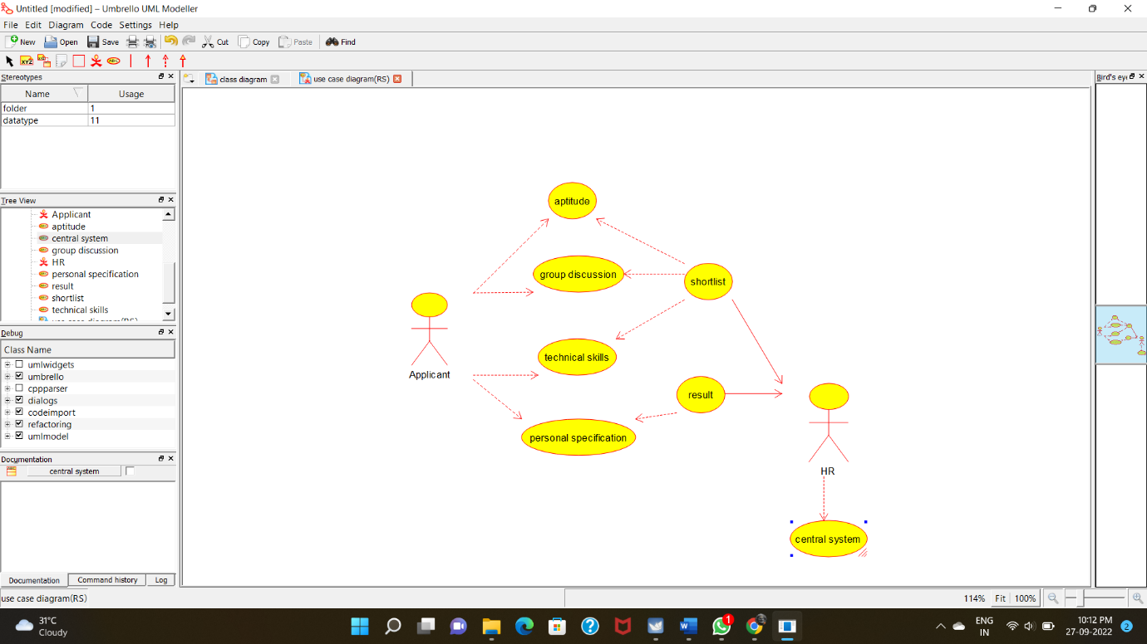

**CLASSDIAGRAM**: 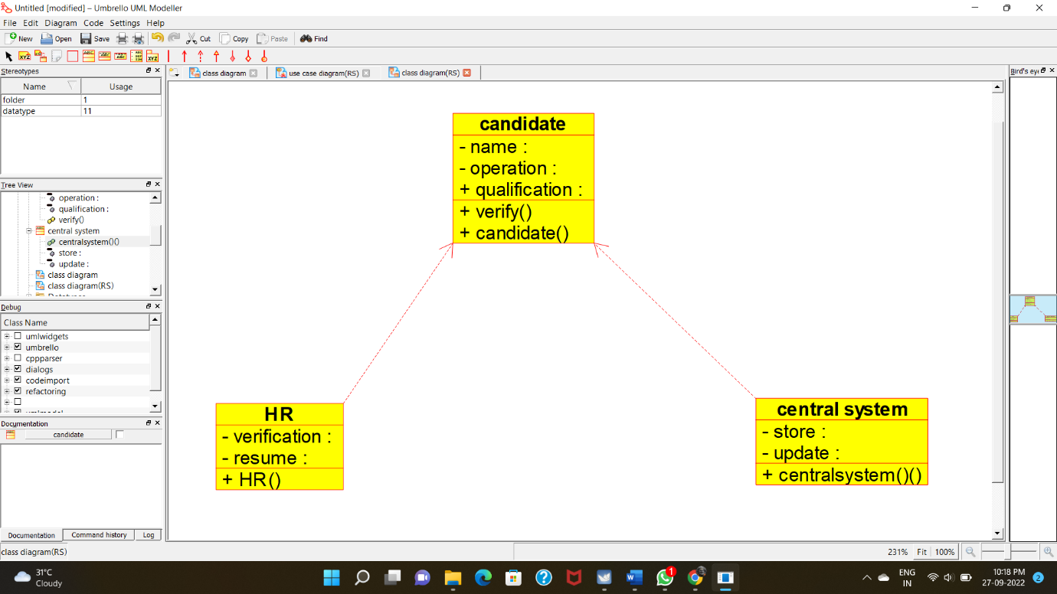

**ACTIVITY DIAGRAM:**

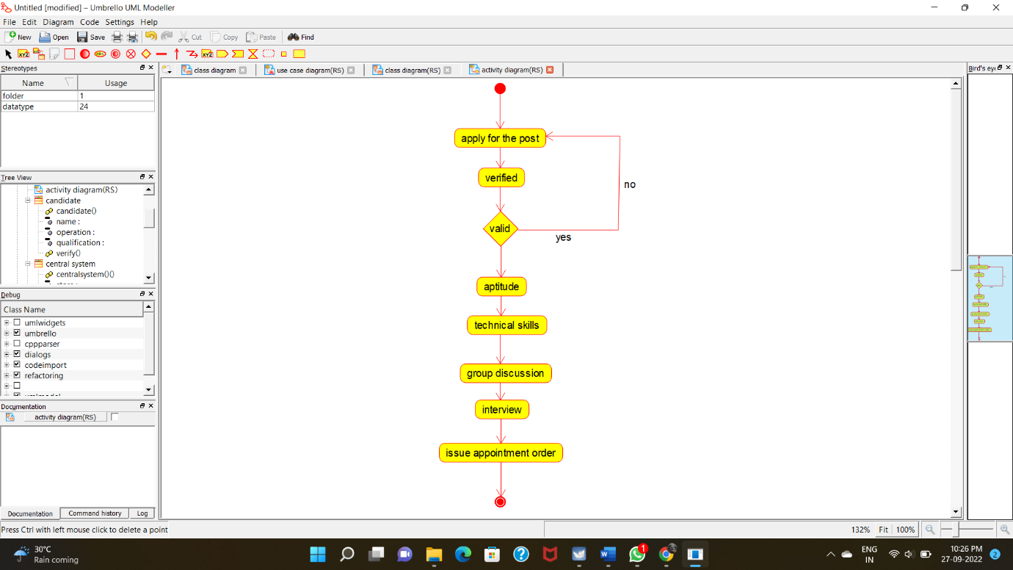

**COLLABORATION DIAGRAM:**

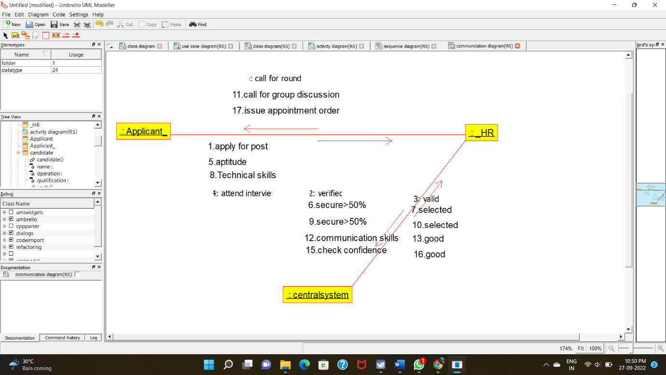

**STATE CHART DIAGRAM:**

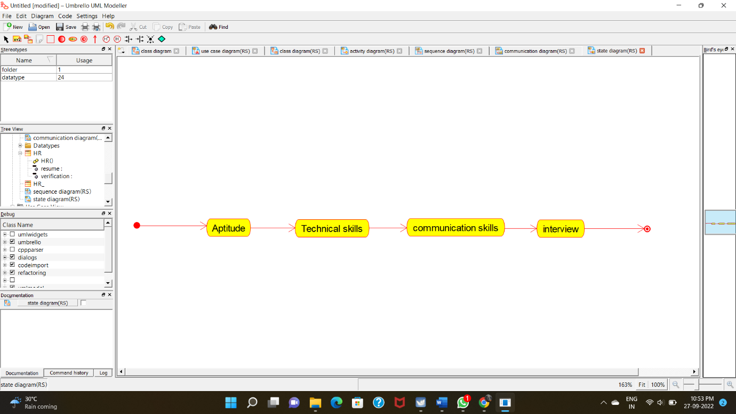

**COMPONENT DIAGRAM:**

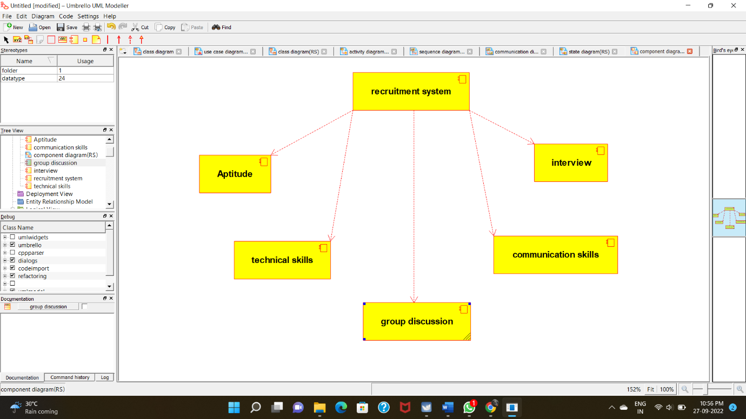

**DEPLOYMENT DIAGRAM:**

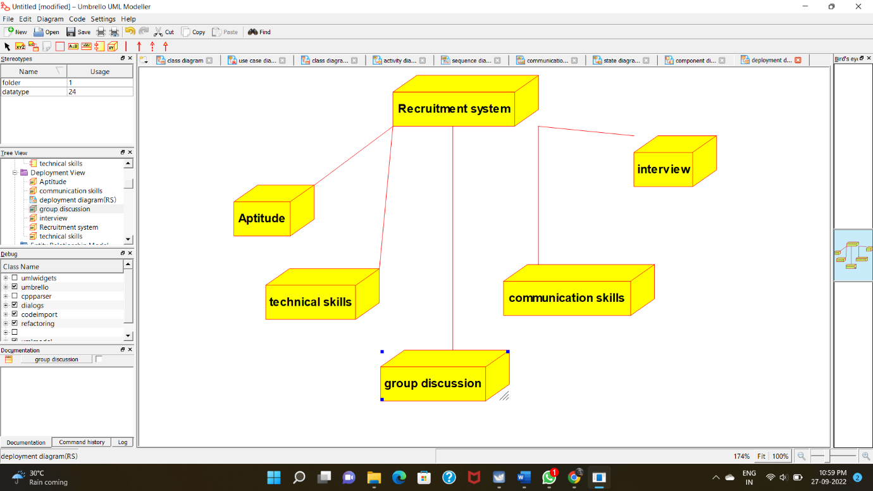

**PROGRAM CODING:**

**CENTRAL SYSTEM:**

**/\*\***

**\* Class central_system**

**\*/**

**public class central_system {**

**//**

**// Fields**

**//**

**private void store;**

**private void update;**

**//**

**// Constructors**

**//**

**public central_system () { };**

**//**

**// Methods**

**//**

**//**

**// Accessor methods**

**//**

**/\*\***

**\* Set the value of store**

**\* @param newVar the new value of store**

**\*/**

**private void setStore (void newVar) {**

**store = newVar;**

**}**

**/\*\***

**\* Get the value of store**

**\* @return the value of store**

**\*/**

**private void getStore () {**

**return store;**

**}**

**/\*\***

**\* Set the value of update**

**\* @param newVar the new value of update**

**\*/**

**private void setUpdate (void newVar) {**

**update = newVar;**

**}**

**/\*\***

**\* Get the value of update**

**\* @return the value of update**

**\*/**

**private void getUpdate () {**

**return update;**

**}**

**//**

**// Other methods**

**//**

**/\*\***

**\*/**

**public void centralsystem_()**

**{**

**}**

**}**

**HR:**

**/\*\***

**\* Class HR**

**\*/**

**public class HR {**

**//**

**// Fields**

**//**

**private void verification;**

**private void resume;**

**//**

**// Constructors**

**//**

**public HR () { };**

**//**

**// Methods**

**//**

**//**

**// Accessor methods**

**//**

**/\*\***

**\* Set the value of verification**

**\* @param newVar the new value of verification**

**\*/**

**private void setVerification (void newVar) {**

**verification = newVar;**

**}**

**/\*\***

**\* Get the value of verification**

**\* @return the value of verification**

**\*/**

**private void getVerification () {**

**return verification;**

**}**

**/\*\***

**\* Set the value of resume**

**\* @param newVar the new value of resume**

**\*/**

**private void setResume (void newVar) {**

**resume = newVar;**

**}**

**/\*\***

**\* Get the value of resume**

**\* @return the value of resume**

**\*/**

**private void getResume () {**

**return resume;**

**}**

**//**

**// Other methods**

**//**

**/\*\***

**\*/**

**public void HR()**

**{**

**}**

**}**

**CANDIDATE:**

**/\*\***

**\* Class candidate**

**\*/**

**public class candidate {**

**//**

**// Fields**

**//**

**public void qualification;**

**private void name;**

**private void operation;**

**//**

**// Constructors**

**//**

**public candidate () { };**

**//**

**// Methods**

**//**

**//**

**// Accessor methods**

**//**

**/\*\***

**\* Set the value of qualification**

**\* @param newVar the new value of qualification**

**\*/**

**public void setQualification (void newVar) {**

**qualification = newVar;**

**}**

**/\*\***

**\* Get the value of qualification**

**\* @return the value of qualification**

**\*/**

**public void getQualification () {**

**return qualification;**

**}**

**/\*\***

**\* Set the value of name**

**\* @param newVar the new value of name**

**\*/**

**private void setName (void newVar) {**

**name = newVar;**

**}**

**/\*\***

**\* Get the value of name**

**\* @return the value of name**

**\*/**

**private void getName () {**

**return name;**

**}**

**/\*\***

**\* Set the value of operation**

**\* @param newVar the new value of operation**

**\*/**

**private void setOperation (void newVar) {**

**operation = newVar;**

**}**

**/\*\***

**\* Get the value of operation**

**\* @return the value of operation**

**\*/**

**private void getOperation () {**

**return operation;**

**}**

**//**

**// Other methods**

**//**

**/\*\***

**\*/**

**public void verify()**

**{**

**}**

**/\*\***

**\*/**

**public void candidate()**

**{**

**}**

**}**